**SCREENSHOTS FOR CREATING ANDROID CAMERA API**

LOGIN

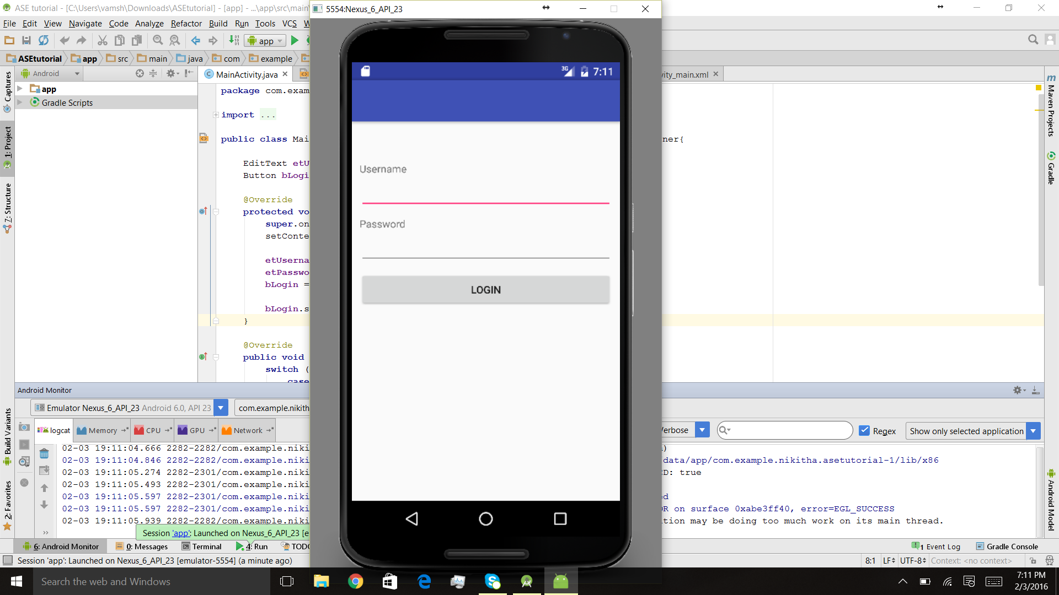

SUCCESFUL LOGIN

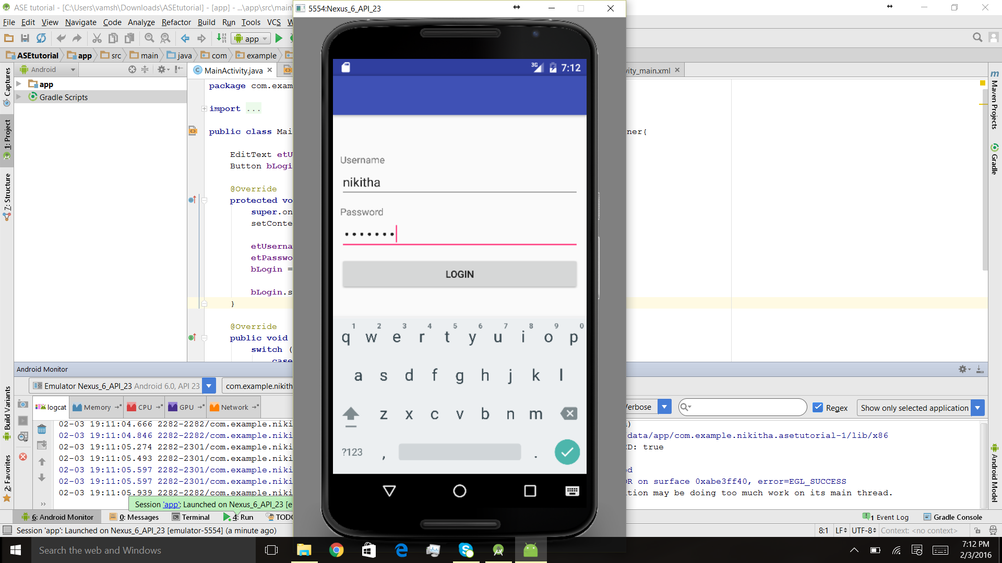

CAMERA API

